

The Parish Messenger

April 2023

Mission Statement

We are a Christian community rooted in God’s love growing in Christ through reaching out and serving.

PASTOR’S PONDERINGS: Pastor Diane Norstad

Dear Georgetown Trinity Parish,

I’m deep into preparations for Holy Week as I write to you today.  It’s such an amazing time of the church year.  No matter how many years as a Christian and now as a pastor that I’ve experience Holy Week it never ceases to amaze me how much God has done for us.  Holy Week is a time when we experience both the highs and the lows of the story of Jesus.  How amazing is it that God gave His only Son?  How amazing it must’ve been to be there as a follower that week?  How crazy is it that people could hail Jesus entry into Jerusalem as a hero and yet have him crucified by Friday?  How can we possibly absorb that God’s own Son died for us and rose again on Easter morning?

This year, where we’re at as a parish isn’t all that different than the upheaval experienced in Holy Week, just on a smaller scale.  The Jews experienced changes in their world and faith that they certainly didn’t expect.  I cannot imagine they enjoyed change any more than the rest of us do.  Now we experience the absence of a beloved pastor and changes to our lives and our parish.  Yes, there will be much change and very little of it asked for.  Yes, also, there will be new life and growth as we arise in our Eastertime as well.  We will find new joys, new people, new ways of doing things, and the resurrection of some meaningful traditions as well.  There ARE good things coming.  God always has a plan.

I ask you to be patient with me, with Diana as she begins her journey as church secretary, and with each other.  More importantly I ask you to be patient with God as God rolls out a new future for us all.

Easter Blessings to all of you from Tim and I.

In Peace, Pastor Diane Norstad

CHURCHES

Georgetown Lutheran

PO Box 86

Balsam Lake, WI 54810

Office: 715.857.5580

Trinity Lutheran

2502 E. Grenquist Lake Ln.

Cumberland, WI 54829

715.822.3001

**PASTOR**

Diane Norstad

715-501-4129 (cell)

715-268-5706 (home)

[revdianenorstad@yahoo.com](mailto:revdianenorstad@yahoo.com)

**WORSHIP TIMES**

Georgetown

Worship 10:30 AM

Trinity

Worship 9:00 AM

**SUNDAY SCHOOL TIMES**

Georgetown

9:00 AM (Sept-May)

Trinity

10:15 AM (Sept-May)

**OFFICE HOURS**

Mondays 9:00 AM– 3:00 PM

**Easter Message from Bishop Laurie Skow-Anderson**

**April 2023**

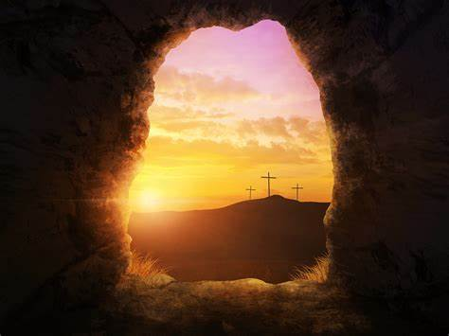*Matthew 28 After the Sabbath, as the first day of the week was dawning, Mary Magdalene and the other Mary went to see the tomb. And suddenly there was a great earthquake, for an angel of the Lord, descending from heaven, came and rolled back the stone and sat on it… the angel said to the women, “Do not be afraid, for I know that you are looking for Jesus who was crucified.**He is not here, for he has been raised, as he said… go quickly and tell his disciples.”*

Dear Northwest Synod of Wisconsin,

Join me and that great cloud of witnesses this Easter in the acclamation:

Christ is Risen,

He is Risen indeed, Alleluia!

The gospel reading for this Easter is from the book of Matthew. Matthew is the only gospel writer that records an **earthquake** on Easter morning. The women arrive at the tomb and are greeted by an earthquake, an angel rolling back the stone, and the news that their Lord and Savior wasn’t there, JESUS HAD BEEN RAISED FROM THE DEAD. What? The women were filled with shock and fear. The aftershocks of this earthquake are still felt. The news that death doesn’t win and is defeated by the power of God in Christ Jesus continues to shock and amaze us.

What if we imagined Easter not as a lovely spring ritual filled with pastel-colored eggs and candy but as the violent earthquake that it is? Few living in the Midwest have experienced an earthquake. A pastor born in California remembers her mother putting rubber bands on the kitchen cupboard handles so the china dishes wouldn’t fall out when there was an earthquake. When has a death of a loved one shaken the foundation of your world? When have you realized how fragile life can be? Christ's resurrection from the dead, his victory over sin, death, and the devil shakes up everything. It is the good news that can even shake us loose from our grief.

What if we experienced Easter as a violent earthquake more like a fresh egg dropped to the floor than one hard-boiled and beautifully decorated? What if the Easter Earthquake shakes us awake, shakes everything out of the cupboards and closets so we are forced to do spring cleaning and decide what to put back and what to throw out? What if we get rid of stuff that doesn't work and give more space to what's important? What is really important? What is God’s will for you? What are our Easter priorities?

What if this year the Easter Earthquake cracks open and rolls away the stone from our hearts, shakes loose old ideas, breaks down rock-hard prejudices, and opens us up to new ways to love our neighbor and to share this amazing good news that Jesus lives? What new life might rise up from the rubble? What new relationships might develop? Like a chick struggles to break free of the egg’s shell, new beginnings are rarely easy, but they are worth it.

The good news is that Christ’s resurrection from the dead and his victory over death is good news even to those who have experienced a literal shifting of tectonic plates beneath the earth. On February 6, 2023, a 7.8 magnitude earthquake hit Turkey and Syria leaving over 50,000 people dead and hundreds of thousands more wounded, displaced, or homeless. More than 10,000 aftershocks have been felt since February 6 leading to more deaths, fear, and trauma. The aftershocks will continue for a long time.[1]

This Easter, in response to the earthquake that opened the tomb and to the good news that Jesus has been raised from the dead, I encourage you to give a gift to the Lutheran Disaster Response to help the victims of the Earthquake in Turkey and Syria. Here is a link to help you do that. <https://community.elca.org/middle-east-crisis?_ga=2.89763675.1129066314.1679579365-256581953.1608055964>

Suddenly there was a great earthquake…

In Christ,

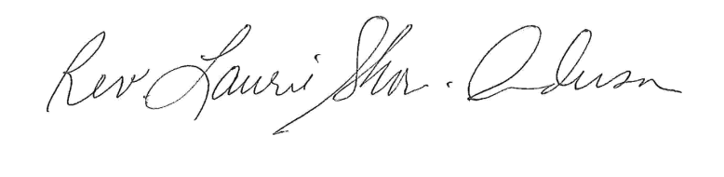

Bishop Laurie Skow-Anderson

**CALENDAR & UPCOMING EVENTS**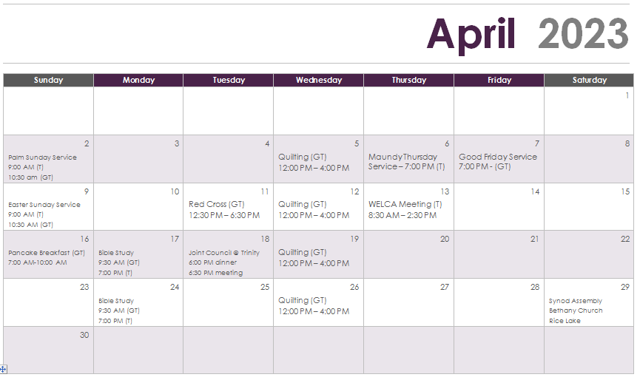



YOUTH EASTER EGG HUNT

Georgetown

Easter Sunday (4/9) – 9:00 AM

Trinity

Easter Sunday (4/9) – 10:00 AM

(youth are invited to help assemble Easter eggs following 4/2 service)







**OUTREACH ACTIVITIES**

At the Wednesday, March 22, Lenten Service, welcome bags and child birthday bags were assembled and donated to the Community Referral Agency (CRA) in Milltown.

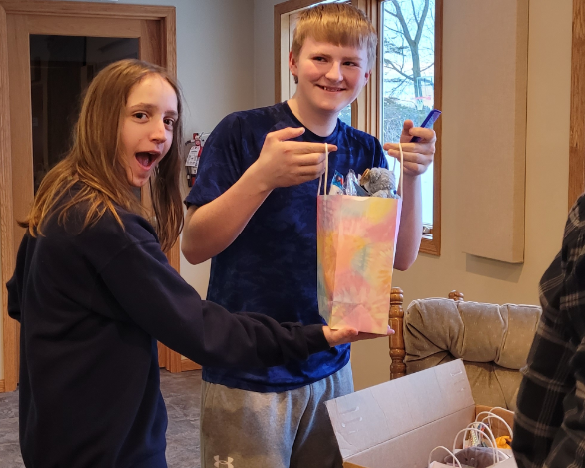 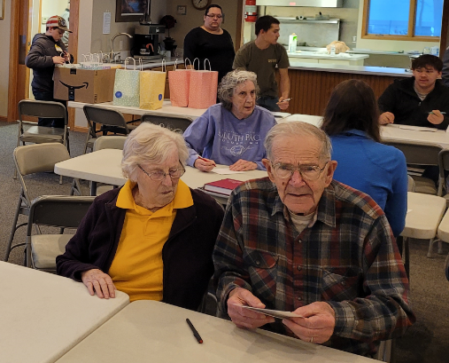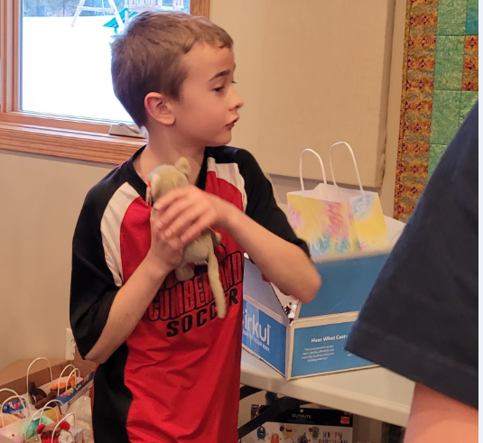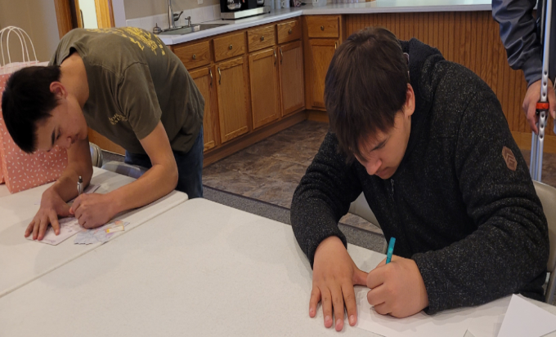 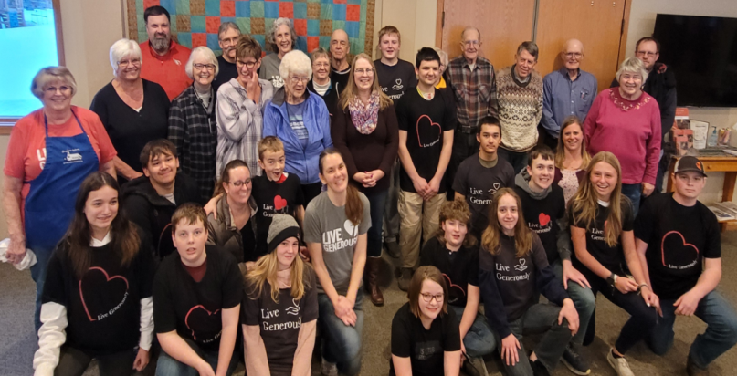

**PALT DINNER**

Trinity held their annual Palt Dinner on Sunday, March 26. A great turnout as always!

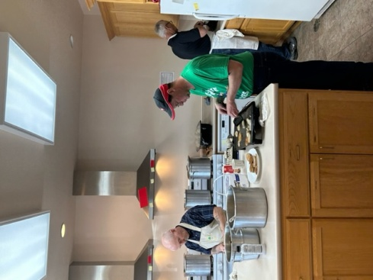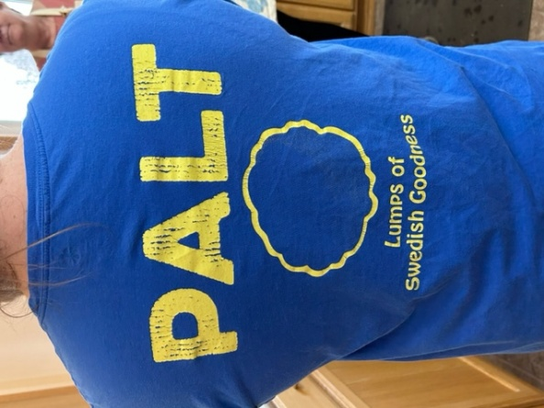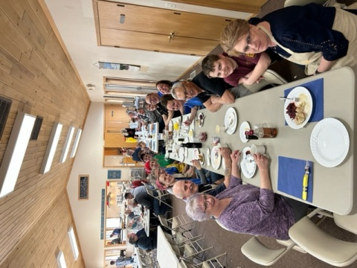

***What is palt you might ask?*** All palt is made of raw potatoes, while the dumplings made out of pre-boiled potatoes are referred to as kroppkakor. This gives the pitepalt a darker color in comparison. Who knew?

**NEWS FROM OUR COUNCILS**

**Georgetown Lutheran Church**

Council Meeting 3/9/2023

6:20 pm

**Attending:** Felicia Braastad, Stephanie Fansler, Sherry Doornink, Nicole Norlund, Ryan Braastad, Dale Jensen, Keith Ward, Roberta Hansen-Treasurer

**Absent:** Pastor Norstad, Bruce Peper, Judy Gammel

Meeting called to order.

Treasurer’s report accepted and approved. Roberta reported that the premium for church insurance through Church Mutual has increased and exceeds our budgeted amount by $795.00.

We are currently $763.25 behind in the budget.

**Old Business:**

Discussion on the proposed Youth/Child Protection Policy. Motion made and approved to table any further discussion on this policy until the joint council meeting in April.

Review of the Water Improvement Grant. Keith demonstrated a water distillation system and the council reviewed information provided by Kinetico/Aquarius water treatment. Dale will contact their representative to set up a meeting with them. Application for the Water Improvement grant was completed and sent.

Long distance telephone calling from the parish office has been updated.

**New Business:**

A Blessings of the Bikes event has been set for May 13th. Discussion on how to include the youth and anyone wanting to ride a bicycle. Nicki Norlund and Felicia & Ryan Braastad will follow-up on the details of this event and the possibility of including bicycle riding etiquette to young the riders. Advertising of this event should include that Motorcycles are for adults and Bicycles are for youth and anyone interested in riding a bicycle.

Pastor Norstad has received a Thrivent grant for a Sunday School and Confirmation project of Birthday bags to be distributed to the Battered Women’s Shelter. Pastor will collect the items and have the youth aid in assembling them.

Next meeting is the joint meeting at Trinity. Supper at 6:00 pm with the meeting following at 6:30 pm

Next Georgetown Council meeting is May 11 at 6:30.

Closed with The Lord’s Prayer.

Motion to adjourn made and approved.

Submitted by Sherry Doornink

**Georgetown February Financial Report**

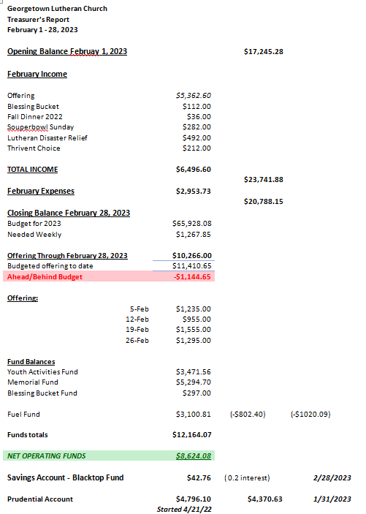

**Trinity Lutheran Church**

Council Meeting Minutes

03/21/2023

**Present:** Pastor Diane Norstad, Mandy Rouzer, Steve Anderson, Rick Sellent, Lacy Sellent, Shane Beecroft

**Missing**: Kathy Grenquist, Deedra Wagner

Shane opened the meeting at 6:30 p.m.

**Secretary’s Report:** Mandy gave the report. Lacy moves, Steve 2nd. All approved. Carried.

**Treasurer’s Report:**

Monthly Income: $7271.51 Offering was $6869.97.

Monthly Expense: $ 7839.10

Net Total: $-567.59

TLC Checking has $7512.19 as of March 21, 2023

TLC Savings has $637.19

MI Fund has $28235.21

Endowment Fund Savings has $39.80

Lunch money collected was $151.47, we had budgeted $250. A total of $401.47 will be distributed to the schools. Luck, Cumberland, Frederic and Turtle Lake will each get a ¼. Kathy was absent, but her report was given. Steve moves, Mandy 2nd. All approved. Carried.

**Pastor’s Report:**  Pastor would like a key for the parsonage. That will be taken care of today. April 29th at Bethany is the Synod Assembly. Would like one male and one female from Trinity to be representatives. Might want to consider electing one male and one female at the Annual church meeting. July 25-27 Tri-Synod Youth Gathering for kids graduating 8th through 12th grade. $50/person. It would be great for some adults to go with the kids. Let Pastor know if you would be interested in going. Continuing education is booked for the beginning of July in England. Safety policy was sent out will be discussed at joint council meeting. No eternal flame. During Holy week we will have Maundy Thursday at Trinity at 7 p.m. and will be doing First Communion, Good Friday at 7 p.m. at Georgetown. Easter 9 a.m. at Trinity, 10:30 a.m. at Georgetown. Would like have a new member Sunday soon.

**Youth Report:** Gathering Easter egg treats, will put them together after Palm Sunday service and hiding them Easter morning. Received an e-mail from the Highway Dept to make sure we would still be picking up trash and we can start anytime after April 1.

**Old Business:**

Eternal Flame – Steve moves to put the eternal flame up. Mandy 2nd. All approved. Carried.

Lighted Cross – tabled.

Outdoor Storage Building – Hwy 48 Equipment $10,050 on skids 16’ x 20’. Premier Buildings – has a 12’ x 20’ for around $7145. An Amish stick built with concrete 16’ x 20’ $12,000 plus we would have to pour slab. Menards - $7355 for 16’ x 20’ materials only plus $3600 for concrete and people to build and pour. Menards – 12’ x 20’ $6659 materials, need to build and add concrete. Steve will call and get a concrete bid. Then council will decide which option to go with via e-mail communication.

Child Safety Policy – will discuss at joint council meeting, looks good so far.

Church Directory – Please send Debbie pictures for the directory to: [Debbie.wickstrom@gmail.com](mailto:Debbie.wickstrom@gmail.com) Debbie would also like pictures of fun events here at church.

Parsonage Maintenance – will discuss at joint council meeting.

Snow Plowing Pay – Travis currently gets $40/time. He is also plowing the parsonage and that will get split between the two congregations. Steve moves to pay Travis an extra $250 in snow plowing. Shane 2nd. Carried.

Water – Lacy applied for a grant to get a new well, or water filtration system. Our water has come back at 9.8, which is less than 10. If we get 4 tests back at less than 10 we can take down our signs.

**New Business:**

Joint Council Meeting w/Georgetown – discuss snow plowing of parsonage.

**Next Council Meeting April 18, 2023 at 6:30 p.m., joint meeting with Georgetown**

Meeting adjourned at 8:40 p.m. on a Steve/Lacy motion. Approved.

Respectfully, Mandy Rouzer

HAPPY BIRTHDAY!

(Baptisms are marked with *)

**April 1**

Doris Gaetz (GT)

**April 2**

Rita Glenna (GT)

Carla Hagen(GT)

**April 6**

Dale Jensen(GT)

Ray Doornbos(GT)

Bayley Ebert(GT)

**April 10**

Molly Hanson(GT)

*Sara Sellent (T)

**April 11**

Jillian Jensen(GT)

Christine Hansen-Weidig(GT)

**April 12**

Marge Filkins(GT)

Diane Veenendahl(GT)

**April 13**

Steve Kelch (T)

**April 15**

Ryan Braastad(GT)

**April 17**

Lacy Sellent (T)

*Jeremylee Stacy (T)

**April 19**

*Cash Rouzer (T)

**April 21**

Jody Binfet(GT)

**April 22**

Ben Anderson

**April 23**

LeAnn Jensen(GT)

Jean Ebert(GT)

Andy Mangelsen(GT)

Juan Ebert

**April 24**

Bridgett Bergmann(GT)

Jim Glenna(GT)

**April 25**

Dennis Anderson(T)

Tom Weaver(T)

**April 28**

Chelsey Jensen(GT)

**April 29**

Dorothy Lauritsen(GT)

If your birthday and/or baptism are missing from the list, please email the church office so lists can be updated.

***************************************************************************************************************************************************

**BRAIN TEASERS OF THE MONTH**

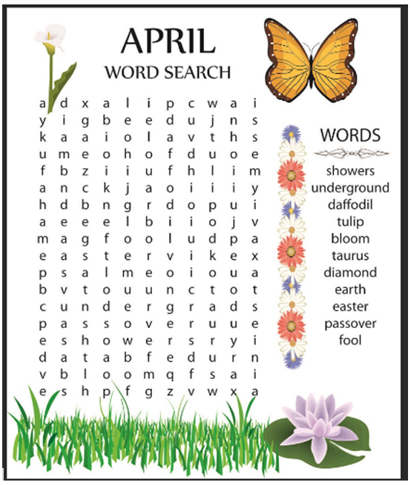

1. https://www.reuters.com/graphics/TURKEY-QUAKE/AFTERSHOCKS/dwpkdzklevm/