The Parish Messenger
June 2023

Mission Statement
We are a Christian community rooted in God’s love growing in Christ through reaching out and serving.

Blessing of the Bicycles – Georgetown

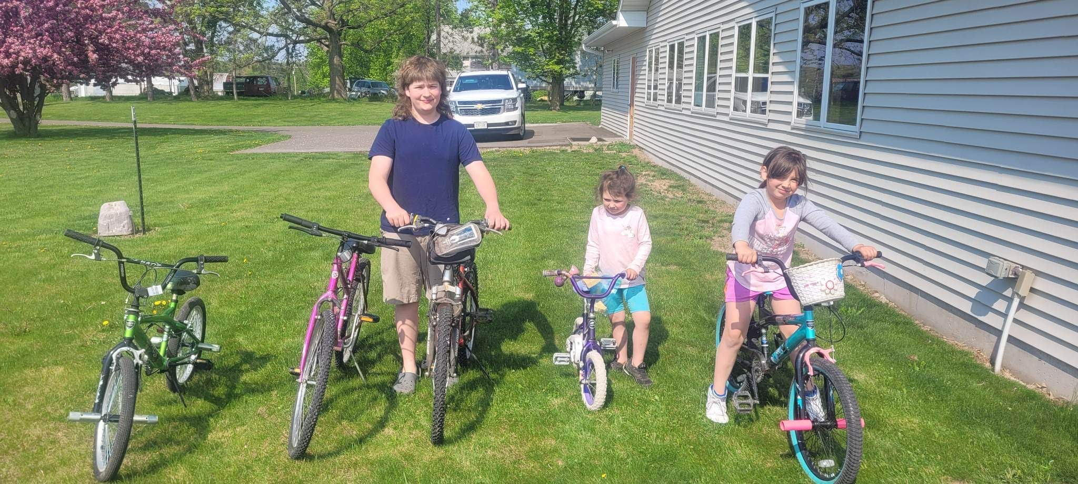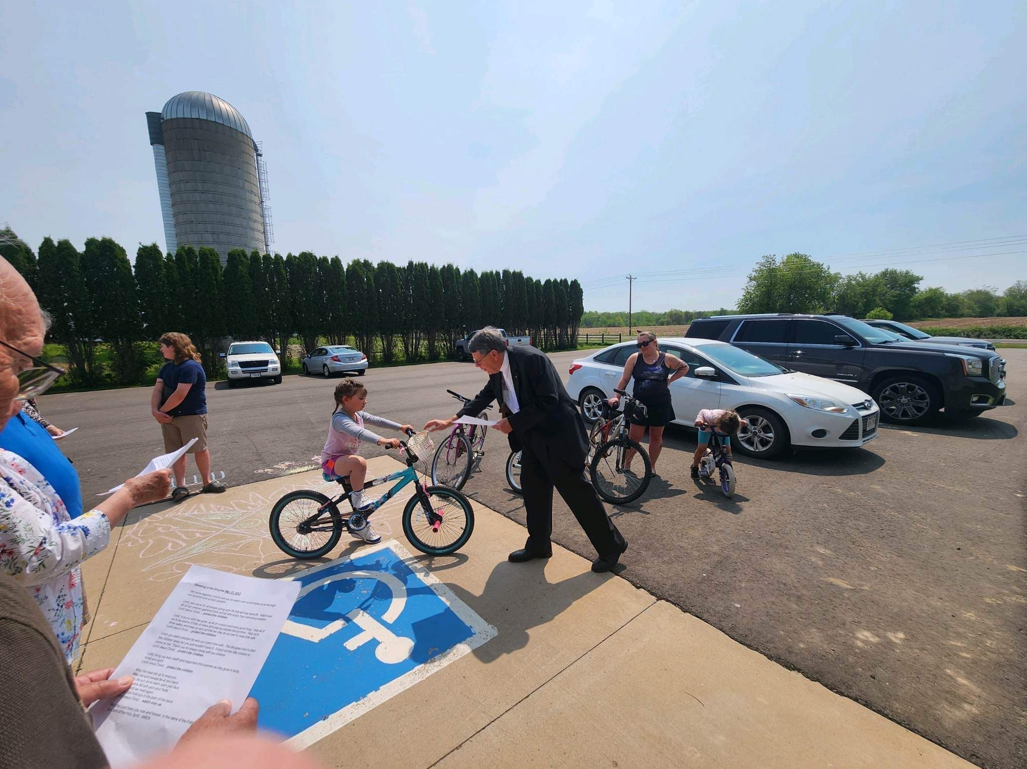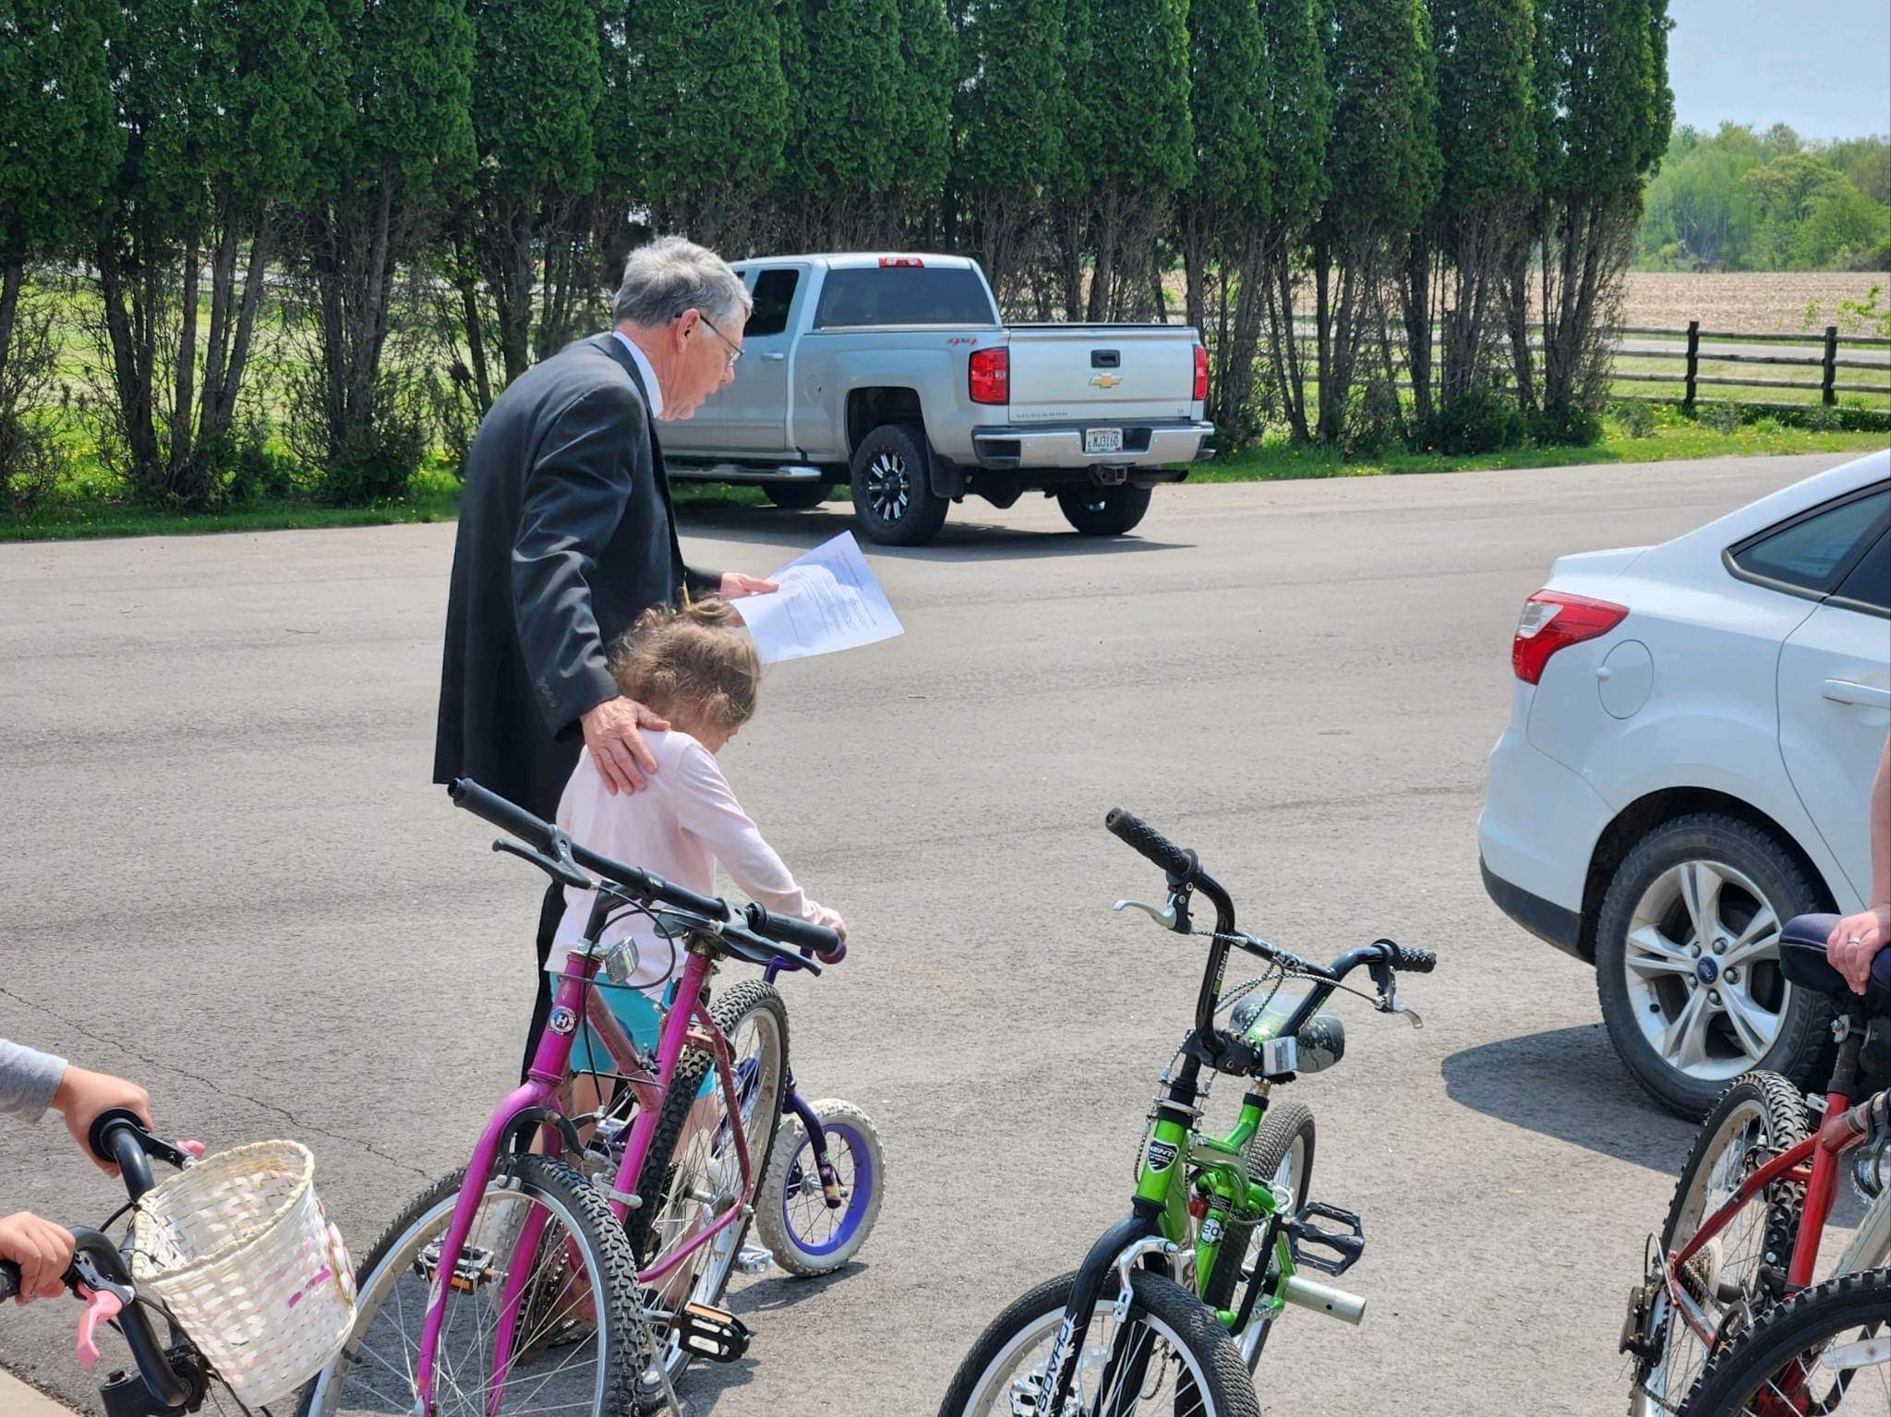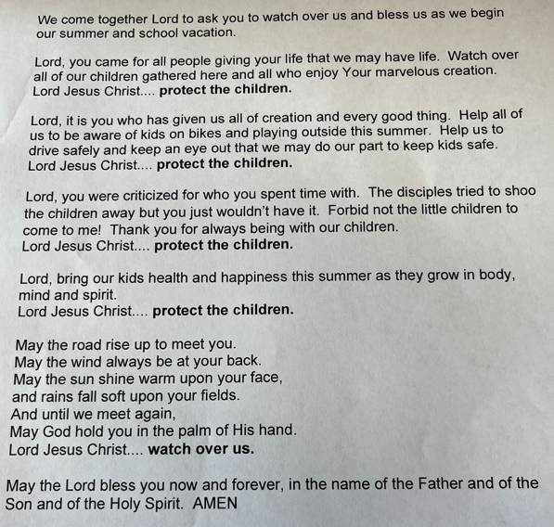

CHURCHES
Georgetown Lutheran
PO Box 86
Balsam Lake, WI 54810
Office: 715.857.5580

Trinity Lutheran
2502 E. Grenquist Lake Ln.
Cumberland, WI 54829
715.822.3001

PASTOR
Diane Norstad
715-501-4129 (cell)
715-268-5706 (home)
revdianenorstad@yahoo.com

WORSHIP TIMES
Georgetown
Worship 10:30 AM

Trinity
Worship 9:00 AM

SUNDAY SCHOOL TIMES
Georgetown
9:00 AM (Sept-May)

Trinity
10:15 AM (Sept-May)

OFFICE HOURS
Mondays 9:00 AM– 3:00 PM

UPCOMING EVENTS
Wisconsin Open House Weekend
Saturday, June 3 & Sunday, June 4

Free fishing and admission to WI state parks and bike trails.

A great opportunity to get out and enjoy God’s Creation!
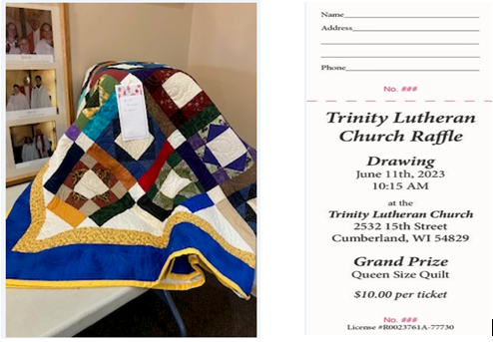

Polk County Dairy Breakfast
Saturday, June 17
7:00 AM – 11:00 AM
Hosts: Neil & Janice Jensen
1938 – 25th Street
Comstock (Pipe Lake)

WELCA Quilting Update
Women of Trinity
Quilting and kit making meeting
Thursday, June 8 8:30 AM – 2:30 PM

Georgetown
Summer quilting will be based on weather. Please contact Teressa Jensen with questions.
Georgetown/Trinity Worship Service
Sunday, June 25
10:00 AM Service
**Softball game to follow service**

ALL AGES ARE WELCOME!
CHURCH HAPPENINGS
Trinity’s Third Endowment Fund
Is Now Open and Fully Invested

The Ministry Growth Fund of the Evangelical Lutheran Church in America’s (ELCA) Foundation has accepted the $2,000 deposit for the fund dedicated to ministries of the ELCA. This new fund joins Trinity’s two other funds: the original fund dedicated to Trinity Church and/or its members and the second, an undesignated fund.
The Ministry Growth Fund is a “market” account whose value fluctuates daily depending upon financial forces. The original fund was opened in 2020 with a $40,000 bequest from Elsie Marklund. At the end of April 2023, the $40,000 investment was valued at $46,462 after $5,000 of withdrawals. The latest $2,500 withdrawal is for the construction of the shed; the first was for part of Jim Springsteen’s educational expenses. The Endowment Committee will open applications for the 2023 gift this fall. The 2023 gift will be disbursed following final approval by the 2024 Annual Meeting.
Gifts to either of these three funds should be clearly marked, including designating which of the three funds the gift is intended for. A desire to give a gift other than a Sunday offering may be discussed with any of the Endowment Committee members: Steve Kelch, chair; Wayne Kendrick, secretary; Christine Anderson, member; Lacy Sellent, council representative; Shane Beecroft, advisory; or Pastor Norstad, advisory.

Respectfully submitted,
Wayne Kendrick
***********************************************************************************************************************
Annual Georgetown Garage Sale
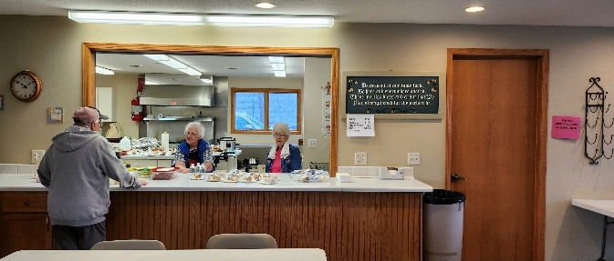
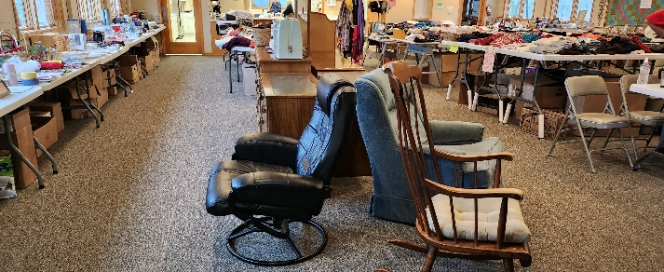
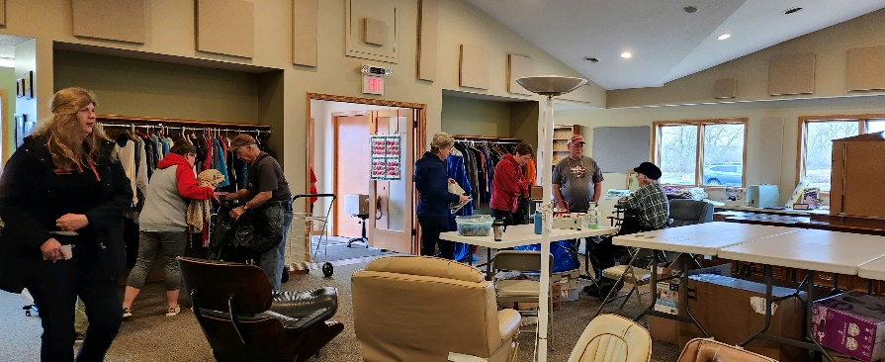
Another successful garage sale was held at Georgetown at the beginning of May. Thank you to all those that helped set up, provided items, and helped with clean up!
THANK YOU! THANK YOU! THANK YOU!

HAPPY BIRTHDAY!
(Baptisms are marked with *)

June 2 Lewi May - T
June 4 Albert Hanson - T
June 12 Wayne Kendrick * - T
June 14 Jerry Denver* - T
June 19 Butch Doornink – GT
June 21 Anna Weaver – T
June 22 Stephanie Fansler – GT
Ben Anderson * - T
June 25 Samuel Grenquist
June 26 Ellen Bergmann - T

If your birthday and/or baptism are missing from the list, please email the church office so lists can be updated.

***************************************************************************************************************************************************

JUNE BRAIN TEASER
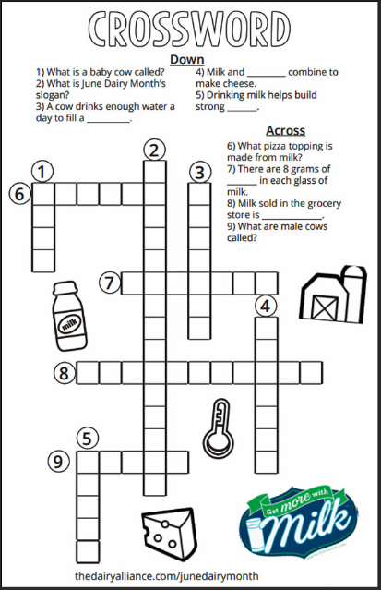

Grace to you and peace!

Summertime! What a wonderful season for renewal.
We’ve accomplished so much this past winter and spring. Thank you to all our Sunday school teachers who have done such a great job. Thank you to our Confirmation students who took on acolyting and Lenten worship leadership with gusto. Well done! Our shepherding teams have also done wonderfully in stepping up during this interim time as well as our councils in their fine work.
Summer is also synonymous with the season of Pentecost. You may have noticed that the color for Pentecost Sunday is red but for the rest of the season it’s green. What’s that about? Green represents new life and growth as we go through the stories of Jesus life and teachings. This is a time to reach out to others and to God as we grow.
This is also sometimes called “ordinary time.” I don’t particularly like that term because the Holy Spirit firing us up at Pentecost for the season doesn’t seem very ordinary to me. Ordinary sounds dull and the Holy Spirit is anything but. We never know what life will bring and that’s the joy of it! Far too often we focus on worrying about the troubles tomorrow may bring and forget to count today’s blessings as well as hope and wonder with joy what God will bring us for tomorrow.
Do you remember when you were in school and waiting with such joy for summer? You weren’t apprehensive or worried about difficulties! We were all looking forward to sunshine and fun. Growing up farming I looked forward to hay baling time with my family and the neighbors. This might just sound like a bunch of work to you – and it was. However, there was joy to be had in the thankfulness for the harvest, joy to be had in a good homemade farm lunch in the field, and joy in the family and neighbors just being together. My brother and I would then save up the penny or two a bale dad paid us for haying to go to the county fair. Mini donuts here we come!
Reminiscing? Sure, but also making a point. There ARE good things to come! God is just around the corner with another wonderful surprise for all of us and for our parish. We don’t often know what those surprises will be but that’s just fine. How human nature came to worry about the future so much without looking forward to God’s blessings is beyond my understanding. Perhaps we should take time to look forward with hope and joy, trusting in the Lord.
Jeremiah 29:11 - For surely I know the plans I have for you, says the Lord, plans for your welfare and not for harm, to give you a future with hope.
So let’s take the time to dream and hope about our parish future in God. While we’re at it, it wouldn’t hurt to have a few mini donuts at the fair either!

Go forth in JOY, Pastor Diane Norstad

Could you use a bit of a boost? Would you like to encounter more perspectives on God’s Word? God Pause Devotions are a great way to grow your faith in the Pentecost season of growth. You can either sign up for them or just read them daily at luthersem.edu/godpause/. Give it a try! It is completely free and sponsored by Luther Seminary, St. Paul, MN.

Hospital & Home Visits

When you are ill or in need of a visit please be aware that it has not been legal for some time for Pastor’s to be informed by hospital staff if you are there. If you or a family member are hospitalized please call the church office to let me know. I have no other way of knowing. In emergencies my home number is 715-268-5706 and cell is 715-501-4129. Be aware that the cell phone often doesn't work well in our area so please leave the message at both numbers if not during office hours. Thanks! Pastor

NEWS FROM OUR COUNCILS
**No minutes available from Georgetown’s May council meeting at this time**
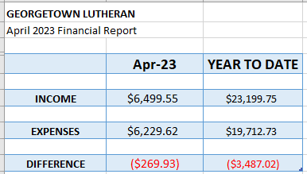

Trinity Church Council Meeting
May 9, 2023

Present: Shane Beecroft, Deedra Wagner, Kathy Grenquist, Rick Sellent, Lacy Sellent, Steve Anderson. Not present: Mandy Rouzer.
Shane Beecroft opened the meeting at 6:40pm.

Secretary’s Report
Minutes were read from March 21, 2023 meeting (April was joint council meeting)
Motion to approve made by Steve Anderson. Second by Lacy Sellent.
Secretary’s Report approved.

Treasurer’s Report (March 2023)
TLC Savings: $637.98
MIF: $28,244.75
Endowment Savings: $40.82
Checkbook Balance (as of April 2023): 6,045.01
Motion to approve made by Steve Anderson. Second by Deedra Wagner.
Treasurer’s Report approved.

Youth Report
Picked up 3 bags of garbage and 4 bags of recycling along our two sections of Hwy 48. Reminder that Saturday, June 3 & Sunday, June 4 is the Wisconsin Open House Weekend--this means free fishing and free admission to WI state parks & bike trails. A great opportunity to get out and enjoy God's creation!
On Sunday, June 25 Trinity and Georgetown will have their second annual softball game to follow a 10am service at Trinity. All ages welcome!

Pastor’s Report
Pastor Diane Norstad will be traveling to England for continuing education first part of July. She will be covering her own expenses.

Old Business
- Steve Anderson to check with an electrician on mounting a light on the peak of the church to illuminate the cross.
- Waiting to hear when cement can be poured for shed—Shane Beecroft checking on land use permit.
- Trinity & Georgetown both discussed and agreed that John may stay at the parsonage, as long as he agrees to do repairs/ upkeep at parsonage (he will be given a list and a timeline in which to finish by). Plan to move in around June 1st. Steve Anderson and Steve Hanson to work on drawing up the agreement. Office phone at the parsonage will be unplugged and the parsonage answering machine will be moved to Trinity church.
- Shane Beecroft purchased mail box to be installed at Trinity church—Deedra Wagner will check with post master to see if there is a preference as to which side of the road the mail box is placed.
- Steve Anderson will check on getting a wedding and funeral policy rough draft together (will look at what Christine Anderson started working on, as well as the funeral policy Georgetown has).
- Had discussion with various local water specialists in regards to treating nitrates at the church. Received quotes that will be passed along to DNR to see if the grant Lacy Sellent applied for last fall will cover its cost. Will likely take some time to hear back.
New Business
- Luther Park was chosen as the Quarterly Mission, which will take place through June
- Motion was made by Deedra Wagner that we resume passing the offering plate during service starting Sunday, June 4. Second by Shane Beecroft. Approved.
- Kathy Grenquist brought up that the money we have in MIF gets 2.5% interest… should we see about getting a higher percentage? Steve Anderson made motion to move $15,000 to a 1-3 year CD at best rate we find—second by Deedra Wagner. Approved.
- Motion made by Lacy Sellent to adjourn the meeting. Second by Rick Sellent. Meeting adjourned at 8:30pm with Lord’s Prayer.
Next council meeting: Tuesday, June 13 at 6:30pm

Respectfully,
Lacy Sellent

