The Parish Messenger
May 2023

Mission Statement
We are a Christian community rooted in God’s love growing in Christ through reaching out and serving.
Celebrating Our Youth

Holy week was full of many things but for these youth, they received their first holy communion. Congratulations! 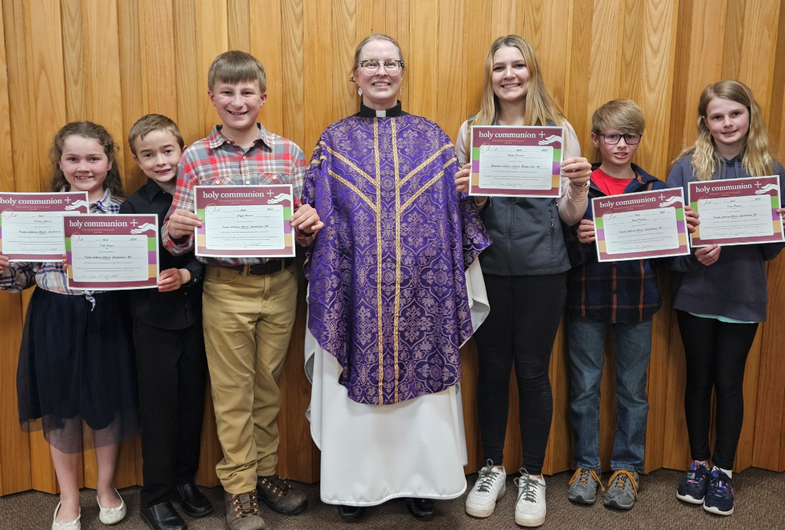
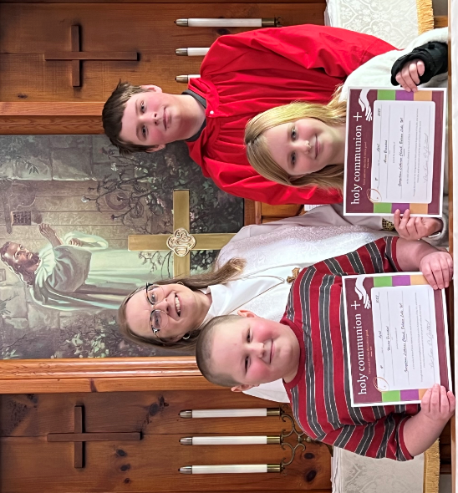

CHURCHES
Georgetown Lutheran
PO Box 86
Balsam Lake, WI 54810
Office: 715.857.5580

Trinity Lutheran
2502 E. Grenquist Lake Ln.
Cumberland, WI 54829
715.822.3001

PASTOR
Diane Norstad
715-501-4129 (cell)
715-268-5706 (home)
revdianenorstad@yahoo.com

WORSHIP TIMES
Georgetown
Worship 10:30 AM

Trinity
Worship 9:00 AM

SUNDAY SCHOOL TIMES
Georgetown
9:00 AM (Sept-May)

Trinity
10:15 AM (Sept-May)

OFFICE HOURS
Mondays 9:00 AM– 3:00 PM

CALENDAR & UPCOMING EVENTS
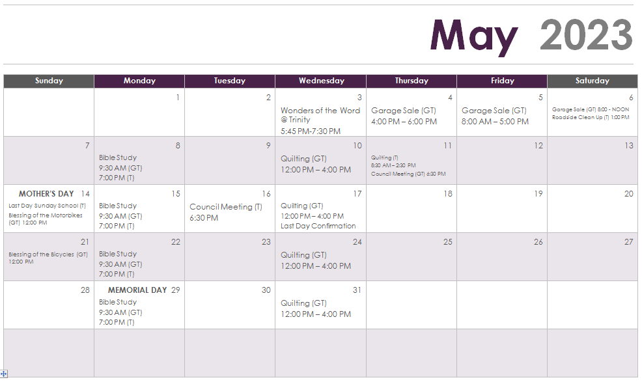
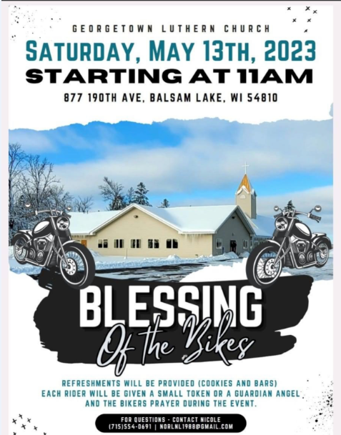

Needing a new handmade quilt to snuggle with?
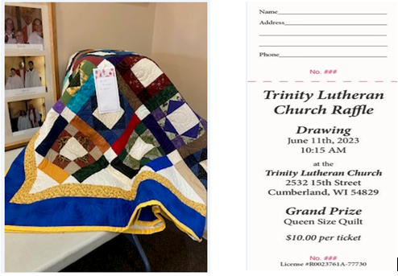
CHURCH HAPPENINGS
Georgetown held their annual Pancake Breakfast to raise money for the Youth Activities Fund. Thank you to all those that donated product, volunteered your time to help prep/serve, and all for attending. We profited over a $1,000! A special thank you to our youth for coming early in the morning and helping!
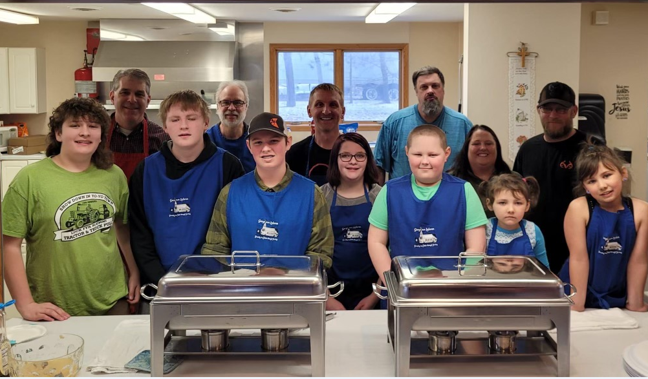

Both Trinity and Georgetown held Easter Egg Hunts the morning of Easter. Thank you to those who donated. The temps were low, but the excitement was high!
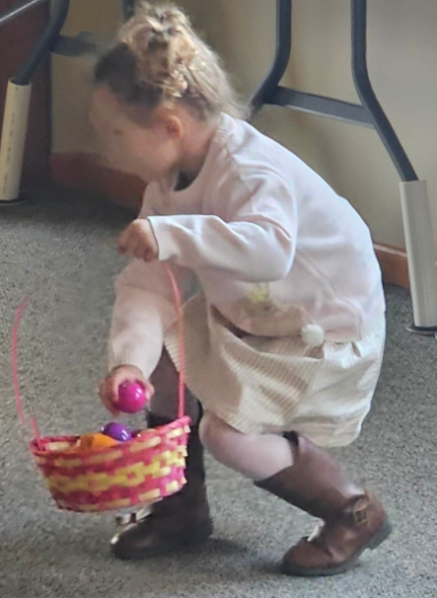
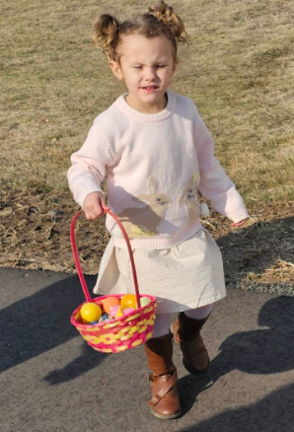

Women of Georgetown attended the Apple River Conference WELCA event at Joy Lutheran Church on Saturday, April 23.
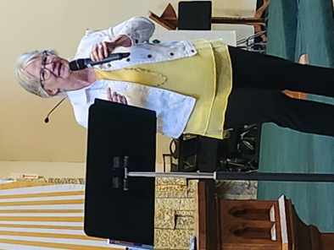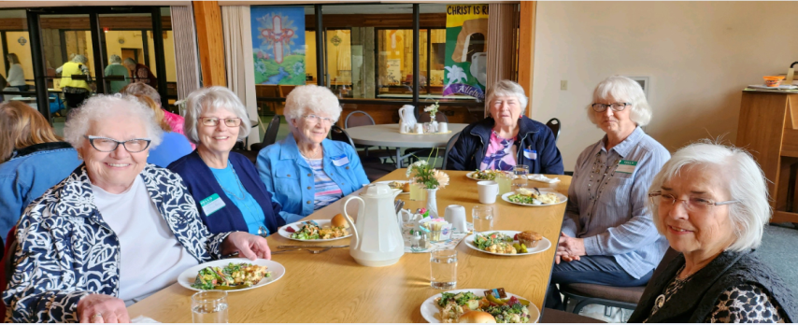

COMMUNITY OUTREACH
Interested in volunteering some time? There are many agencies in our area that rely on volunteers every day!
- Healthy Burnett: Check out the volunteer tab on the Healthy Burnett website for volunteer opportunities in Burnett County: http://healthyburnett.org
- Polk County Fair: http://polkcountyfair.com/volunteer-opportunities/
- Interfaith Caregivers of Polk County: http://www.interfaithpolk.org/volunteer_faq.htm
- Salvation Army: http://polkwi.volunteerfirst.org/
- Wild Rivers Habitat for Humanity: http://www.wildrivershabitat.org/content/volunteer-habitat
- St. Croix Health: https://www.scrmc.org/about/volunteer-partners/
- Family Pathways: http://www.familypathways.org/family-pathways-volunteers/volunteers
- Lions Clubs: https://www.lionsclubs.org/en/start-our-approach/cluc-locator/results
- Kinship of Polk County: http://polkkinship.org/
- Aging & Disability Resource Center of Northwest Wisconsin: https://adrcnwwi.org/volunteer/
Loaves and Fishes Monthly Report
Open Tues. & Thurs. 11 am- 1 pm
Lions Hall, 300 W. 3rd Ave. Luck, WI
P.O. Box 554 Luck, WI 54853

April 2023
# Households served 38 Unity 15
Adults 61 Luck 23
Children 14
Total People 75
Pounds per person sample: 20.53#
Donations: 872# Money $912.58
Volunteer Hours: 41.5 hours

We need more volunteer workers. Please call Pam Girtz 320-232-7541 for more information.

Needs for next month: bread, eggs, milk, cheese, fresh vegetables (carrots, potatoes), fresh fruit
(apples, oranges), canned meat, dish soap, lotion, toothpaste, toothbrushes, paper towels.

New Community Food Pantry
Our Lady of the Lakes Catholic Church has teamed with Faith Lutheran and Joy Lutheran to open a community food pantry.
Feed My Neighbor, Inc.
316 Wisconsin Avenue, Centuria
Hours: Monday 2:00 pm – 5:00 pm
Tuesday 5:30 pm – 7:30 pm
Thursday 10:00 am – 2:00 pm
Saturday 9:00 am – 11:00 am
HAPPY BIRTHDAY!
(Baptisms are marked with *)

May 2 Kristina Norlund Murphy (GT)
May 4 Jeremiah Gorne (GT)
May 5 Ryan Peterson (GT)
May 6 Jeff Bergmann (T)
May 10 Zachary Peterson (GT)
Joshua Gorne (GT)
May 13 Cole Kuschel (GT)
Elizabeth Knutson (GT)
May 15 Charlotte Peper (GT)
May 16 Jordan Jensen (GT)
May 20 Kelly Grenquist (T)
Lacy Sellent (*)(T)
May 21 Natasha Gorne (GT)
May 23 Wesson Braastad (GT)
Loren Monson (GT)
May 29 Vern Olson (GT)
Lacy Chitty (GT)

If your birthday and/or baptism are missing from the list, please email the church office so lists can be updated.

***************************************************************************************************************************************************

MAY BRAIN TEASER
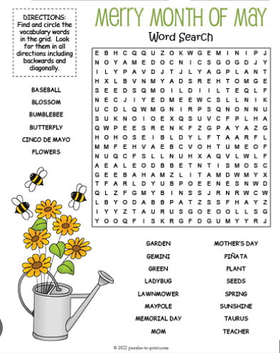

Grace to you and peace!

Spring is almost here! Really! It's time for the fun and renewal that spring will bring. Spring is a time of new life.
A wonderful sign of new life that I’ve been watching is the wonderful number of swans in our area. Did you know that they were considered extinct in 1900? God has given us a wonderful sign of renewal and hope right in our midst. People had thought that it was over for these beautiful creatures. God had a different idea!
Are there things in your life that you’ve given up hope on? Not like dreams of being a cowboy or runway model. I mean serious things. When life looks at its toughest our outlook is not the last word. Just because we think hope is lost (as for the swans) God may have a very different plan for us. God can and does bring new life even when we can’t imagine that it will come.
It may or may not look like what we want but it will be what we need. As I've seen on a most wonderful church sign, “God answers prayers, not advice.”
We don't know what the future may hold but during this time of interim we're exploring, pondering, praying and finding new life. God knows what is best for us. God will provide.

Psalm 71:5
For you, O Lord, are my hope, my trust, O Lord, from my youth.

As spring brings new life, let’s open our hearts to the new life that God gives to us as well. Let’s enjoy spring with hope in our hearts!
Happy to partner with you in faith, Pastor Diane Norstad

Hospital & Home Visits

When you are ill or in need of a visit please be aware that it has not been legal for some time for Pastor’s to be informed by hospital staff if you are there. If you or a family member are hospitalized, please call the church office to let me know. I have no other way of knowing. In emergencies my home number is 715-268-5706 and cell is 715-501-4129. Be aware that the cell phone often doesn't work well in our area so please leave the message at both numbers if not during office hours. Thanks! Pastor

NEWS FROM OUR COUNCILS
Trinity/Georgetown Joint Council Meeting
April 18, 2023
Present: Bruce Peper, Rick Sellent, Lacy Sellent, Kathy Grenquist, Shane Beecroft, Deedra Wagner, Judy Gammel, Stephanie Fansler, Ryan Braastad, Felicia Braastad, Keith Ward, Dale Jensen, Roberta Hansen, Sherry Doornink, Pastor Diane Norstad, Steve Anderson, Nicole Norlund, Mandy Rouzer
Shane Beecroft opened the meeting at 6:45 p.m. after a delicious supper.
Pastor Diane led opening devotions.
What is great about the joint parish? Previous pastors, joint Bible schools, joint softball game, new members are welcomed at both churches, acceptance at both churches, intergenerational activities, comfortable with both churches, friendships/bonding, we’re all a big family, joint youth activities, music department/joint musician coverage, history/building parsonage together, helped building churches, etc., joint council meetings, diversity of pastors, final blessing, amazing youth, together since June 1, 1956.
Previous Minutes: Shane read the previous minutes. Lacy moved, Deedra 2nd to accept minutes, all approved. Carried.
Pastor’s Report: Congregations are working together well. Things get taken care of. Confirmation is going great. Working to get back to “normal”. Confirmation will be on Reformation Sunday, the last Sunday in October.
Old Business:
Child Safety Policy - some concerns about not having two adults available at all times. Need a background check on those working with youth, takes just a few minutes to run it. Keep a copy of registration forms at both churches. Steve moves to adopt the presented Child Safety Policy amongst both congregations, Bruce 2nd, all approved, carried. Each council will add to their next agenda to approve individually as well.
Parsonage Maintenance – most repairs are minor. Furniture left behind was for the churches to do with as we felt necessary. Churches feel keeping furniture at this time for possible use for youth lock-ins at this time. Will pick away at it, but will wait to do the majority until we call a new Pastor.
Other Old Business –
New Business:
Pastor’s Suggestions – Would suggest streamlining things a bit more. It would be nice to have the same policies for both churches, with different sections within for a specific church. Wedding/Funeral/Baptism service policies aside from the current building use policy are needed. However, Pastor has the final call for all services and whether or not they are performed within the church. Pastor created a new membership form and will use the form for both churches. Would like to have a new member service at both churches. Please encourage guests to sign the guest book. Would like a volunteer from each church to send a note welcoming them. We don’t typically send anyone to Synod Assembly and that needs to change. Shane is going from Trinity. Pastor will attend one council meeting one month and the other the other month. Diana (Secretary) suggested a new way to put in financials into the newsletter.
Next Steps for Calling a Pastor – There are 37 openings with only 2 coming out of seminary. Call committee should be made up of equal number of people from each congregation including at least one from each council. We need to fill out the congregational assessment tool. First step is to get a call committee together. Have goals to work towards. We will get 4 from each congregation, then that group will connect with Pastor Randy Olson to move forward.
Joint Activities – Joint church service at Trinity at10 am with potluck lunch and softball game at the end of June, June 25th. Joint animal service on August 13th at Georgetown at 10 a.m.
Use of Parsonage – someone is interested in living in the parsonage for a time, up to a year, roughly. The person would live there rent free while fixing things up and would pay for the utilities.
Date of next council meeting – Joint Council Meeting on Thursday, October 5th at 6 p.m. at Georgetown.
Other new business -
Lenten Offering – Offering went into the account of whichever church hosted that night.
Kid’s VBS – a crew will work on dates.
Blessing of the Bikes – will be on Saturday, May 13th at 11 am at Georgetown Sunday May 21st will be blessing of the bicycles at Georgetown after church, around noon.
Motion by Nicole, 2nd by Sherry to adjourn. All approved. Meeting adjourned at 9:15 p.m.
Respectfully, Mandy Rouzer
